**Denominators Team – VMMC Update**

Contents

December meeting 2

January Meeting 3

Solution for improving the accuracy of VMMC Estimates – Meeting with Modeling Group 4

Appendix A 5

# December meeting

**Who attended**

Jamie, Carlos, Roma, Josh, Jeff and Matt (London), Valerian, Alison, Steph, Parviez

**What was discussed**

Issues with DMPPT2 tool: issues with data that goes into the model; District changes frequently; Correct baseline data is not entered

We need to understand how to deal with the discrepancies with input data. This will be essential if a new tool will be developed.

Should we build on the existing tool or build a new tool from scratch?

Where should the tool reside? - Standalone tool/ Spectrum - Goal is to house the tool in Spectrum

Review of the DMPPT2 tool was done on March - discrepancies was found in the tool. Conclusion in March was that the tool is not the reliable source of information.

Why is DMPPT2 tools not the part of Spectrum? - Consumer of VMMC data is slightly different from UNAIDS estimation process. VMMC estimates are used more for national strategic planning and not the core part of estimates process. Jeff to conform the answer from John Strover.

**Next steps**

**Work on creating a Validated and harmonized VMMC estimation tool which will be housed in Spectrum and possible ready to use by COP 21, which will be updated annually to produce age specific national and district estimates available to HQ and field offices.**

Make a tool that will take in information, populate the data pack for us and is streamlined with MER indicators.

DMPPT2 tool presentation on December 10th (denominators monthly team meeting)

Involve SEM team and UNAIDS Mary/Jeff into the process of creating a new tool

Work on developing a process for cross harmonization with other data sources

Work on setting up process - ministry ownership or global? Cross-harmonization won't be possible if only MoH is involved.

Who will work on the tool - multi country technical body should work on it

Jeff - (in terms of process) to bring the VMMC discussion back to the reference group for harmonization process with the Spectrum.

**Countries identified** – Swaziland, Uganda

Feedback Received – None

# January Meeting

**Who attended**

jodavis@usaid.gov; Davis, Stephanie Marie; ayansaneh@usaid.gov; Toledo, Carlos; Houston, James C; jeffrey.eaton@imperial.ac.uk; acheng@usaid.gov; vkiggundu@usaid.gov; Abellera, John P., Shiraishi, Ray, Thomas, Matthew L <matthew.thomas@imperial.ac.uk>; Stevens, Oliver H E <o.stevens@imperial.ac.uk>; Gutreuter, Steven, Steven Forsythe <sforsythe@avenirhealth.org>; Peter Stegman <PStegman@avenirhealth.org>; Michel Tchuenche <JMTchuenche@avenirhealth.org>; John Stover <JStover@avenirhealth.org>; MAHY, Mary <mahym@unaids.org>; ZEMBE, Lycias <ZembeL@unaids.org>; csayikanmi@usaid.gov; [cnichols@usaid.gov](mailto:cnichols@usaid.gov)

**What was discussed**

Everybody agreed that conceptually the model is sound, but there are issues with the quality of input data that feeds into the model for producing estimates. Katharine and Aisha mentioned cases where survey data for estimating baseline circumcision data was not of good quality. This cause VMMC estimates to be unreliable and this gap widens further when countries get closer to saturation (as per Carlos and Katharine). Kenya paper could be a good resource to understand the reasons and sources of discrepancies and using data triangulation to estimate age-specific coverage of voluntary medical male circumcision for HIV prevention[1].

It was pointed out by that modeled (DMPPT2) and survey coverage estimates for the same year and group sometimes disagree profoundly at national level. The gap increases further at sub-national level. Examples were also provided for multiple countries. See Appendix A for detailed analysis.

Jeff suggested the use Small Area Estimation methodology to enhance the ability of the DMPPT2 tool to estimate district levels targets and coverage of VMMC. Jeff also mentioned the similar work they are doing in South Africa where they are trying to use HSRC survey data to do district level estimates of coverage over time that combines data from all surveys as well as program data. Although, its worth pointing out that unearthing discrepancies is easy but incorporating all the discrepancies into the model may require a bit more effort and research.

It was also noted that process and timeliness of the estimates is important. It was pointed out by Jeff that not only are circumcision coverage estimates relevant for the VMMC program, there is an increasing demand from countries that their VMMC program is reflected in their incidence estimate that comes out of EPP.

John concluded that in order to apply statistical approach to combine multiple sources of data to make the best statistical estimate, the issue of data quality and uncertainty should be resolved first. He suggested that a process should be put in place for an in-depth examination of data from countries. Data should also be reviewed by all stakeholders to reach consensus around coverage estimates.

**I suggest a few next steps**

1. A process should be put in place to examine input data.
2. The estimates from the model should be reviewed by all stakeholders and all stakeholders should reach on a consensus on the estimates.
3. To improve the timeliness of the estimates, they should be included as part of the annual HIV prevalence estimation process.
4. Use already available small area estimation statistical models or data tribulation (like Kenya study) to improve the VMMC coverage estimates at district levels.

Feedback Received – Not yet shared with USAID

# Solution for improving the accuracy of VMMC Estimates – Meeting with Modeling Group

In South Africa, Jeff’s team have tried to estimate circumcision rate over age and time based on age pattern of circumcision in successive surveys using survival analysis approach. The model was able to capture the changing age pattern and rate of circumcision over time. The model captured the difference in rates of circumcision before and after VMMC program. Before VMMC program began, the model showed that most circumcisions happened either during births or in teens (as reflective of traditional circumcisions) but post 2008, the model showed a spike in circumcisions in 10-30 age group which reflect the VMMC program.

Predicting the rate of circumcisions is the most important step in estimating VMMC coverage. Next planned steps are

1. Integrating VMMC program data about number of MCs conducted into the model.
2. Separate components in the model to estimate the traditional and medical circumcision rates.
3. Using Small Area Estimation methodology to disaggregate the national numbers to sub-national level.

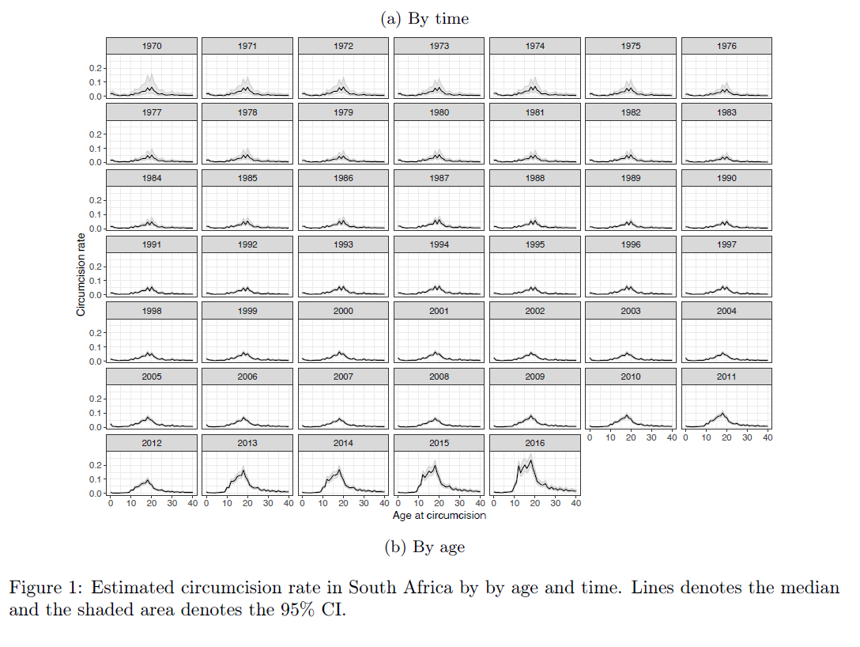

# Appendix A

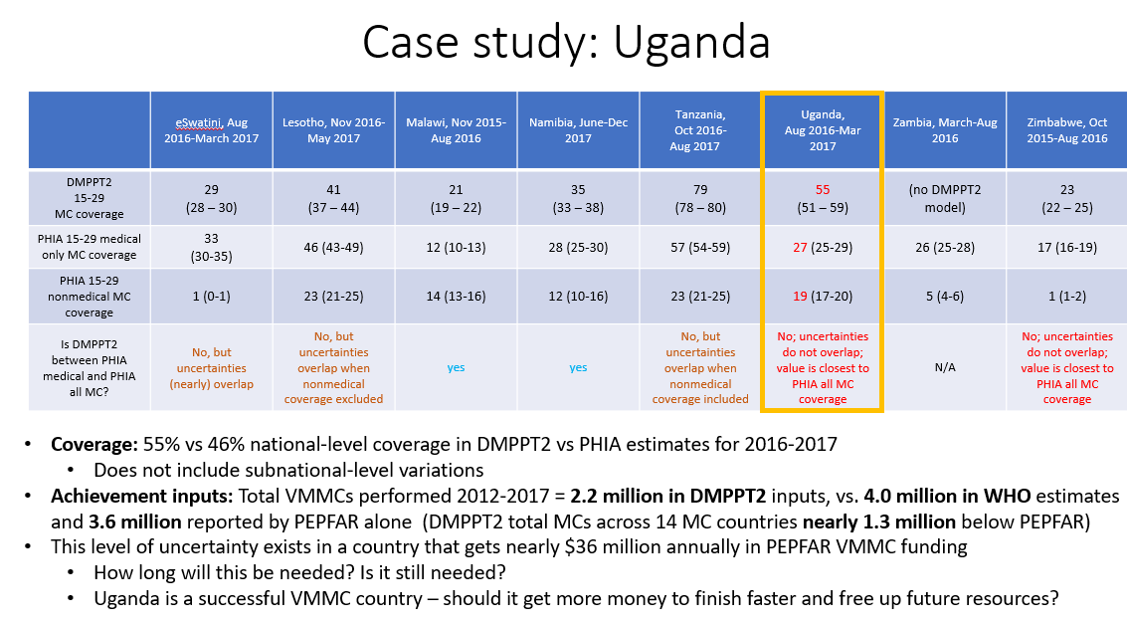

1. <https://www.ncbi.nlm.nih.gov/pubmed/30562394>